Jamile Thomas II

2/24/19

Program 1: Rectangle

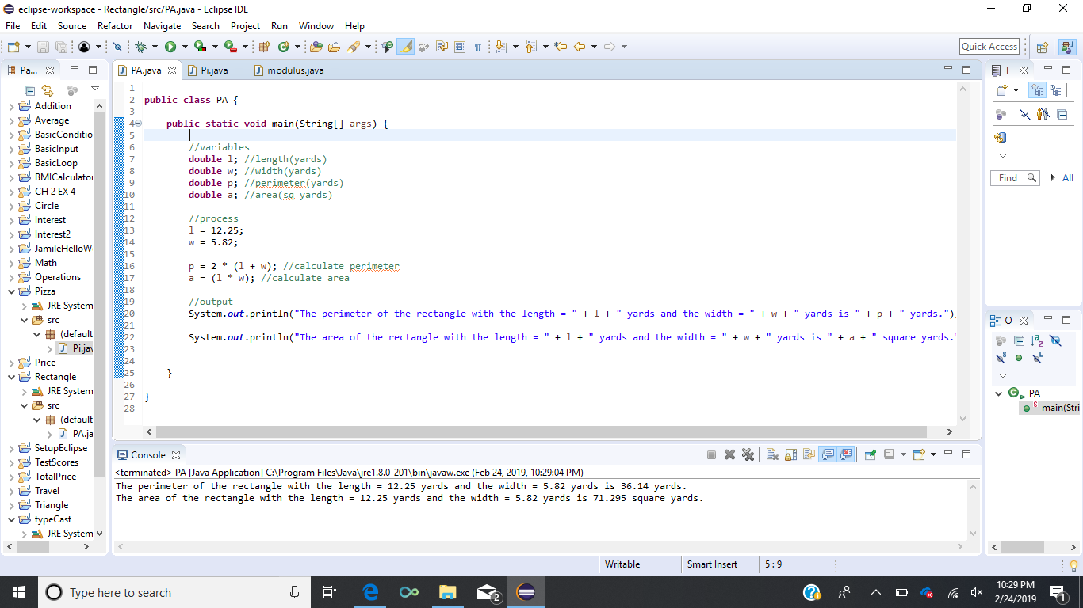

Program 2: Pizza size and price

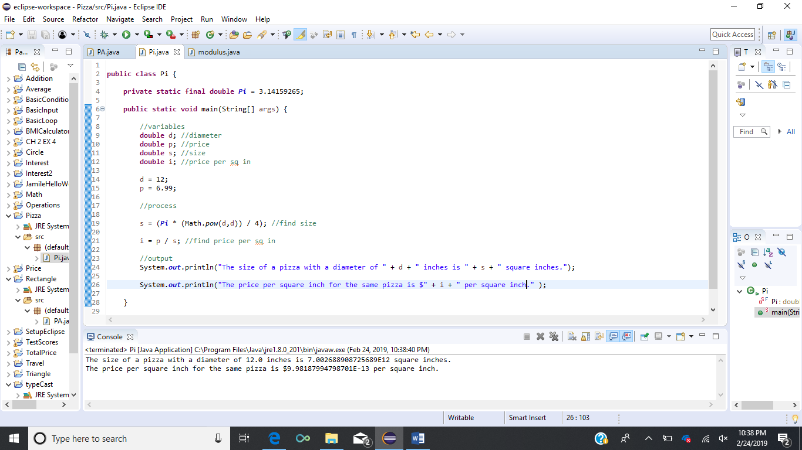

Program 3: Simple Math Operations

